**Topic:** **STAMP COLLECTION** 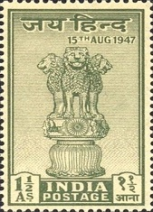

END TERM REPORT

**NAME OF THE CANDIDATE(S):**

|  |  |
| --- | --- |
| SECTION-K19PA |  |
| NAME:- | ROLL NO. |
| SIJOUSA BORO | 51 |
| JHA ANIKET SHIVANAND | 56 |
|  |  |



**DEPARTMENT OF INTELLIGENT SYSTEMS**

**SCHOOL OF COMPUTER SCIENCE AND ENGINEERING**

**LOVELY PROFESSIONAL UNIVERSITY, JALANDHAR**

**10th April-2019**

STUDENT DECLARATION

This is to declare that this report has been written by us. No part of the report is copied from other sources. All information included from other sources have been duly acknowledged. We aver that if any part of the report is found to be copied, we shall take full responsibility for it.

SIJOUSA BORO

ROLL NO: 51

REG NO:11912188

JHA ANIKET SHIVANAND

ROLL NO:56

REG NO:11912130

Place: Lovely Professional University Jalandhar,Phagwara

Date:10/04/2020

**TABLE OF CONTENTS**

**TITLE** **PAGE NO.**

|  |  |
| --- | --- |
| **1. Background and objectives of project assigned ................** | **1** |
| **1.1** ........................................................................................ | 1 |
| **1.1.1 ....................................................................................** | **3** |
| **1.1.2 .....................................................................................** | **5** |
| **1.2 .........................................................................................** | 7 |
| **1.2.1 .....................................................................................** | **7** |
| **1.2.2 .....................................................................................** | **9** |
| **1.2.3 .....................................................................................** | **10** |
| **2 Description of Project ... ........................................................** | **14** |
| **2.1 ..........................................................................................** | **17** |
| **2.2 ..........................................................................................** | **18** |

Background and Layout of the Project:

STAMP COLLECTION

* The purpose of this STAMP COLLECTION website is to provide general information for visitors that may be interested in collecting stamps and to provide the specialized information needs of more advanced stamp collectors and philatelists.
* Stamp collecting is generally accepted as one of the areas that make up the wider subject of philately, which is the study of stamps. A philatelist may, but does not have to, collect stamps. It is not uncommon for the term *philatelist* to be used to mean a stamp collector. Many casual stamp collectors accumulate stamps for sheer enjoyment and relaxation without worrying about the tiny details. The creation of a large or comprehensive collection, however, generally requires some philatelic knowledge and will usually contain areas of philatelic studies.

In this project we have used HTML(Hyper Text Markup Language), CSS(Cascading Style Sheet ),

Javascript, Jquery.

In this website user can find various STAMPS belonging to various country in different era of Time.

User can get the information on Particular Stamps depending on their origin and history related to it.

**Description of Project**

* **In this website USER can find various COUNTRY STAMPS In Category option**

**In which there are total of 10 Country Name along with their stamps.**

**In that all the stamps shown in that particular country option with the information of that particular stamps.**

* **This website carry options like FAQs about the stamp collection ,in that user can find various answer of the question that will arose while going through**

**this website.**

* **In this there are sections like INFORMATION where user can get information**

**About Philatelist terminology, Philatelist meaning etc.**

**OUTLINE OF THE PROJECT:**

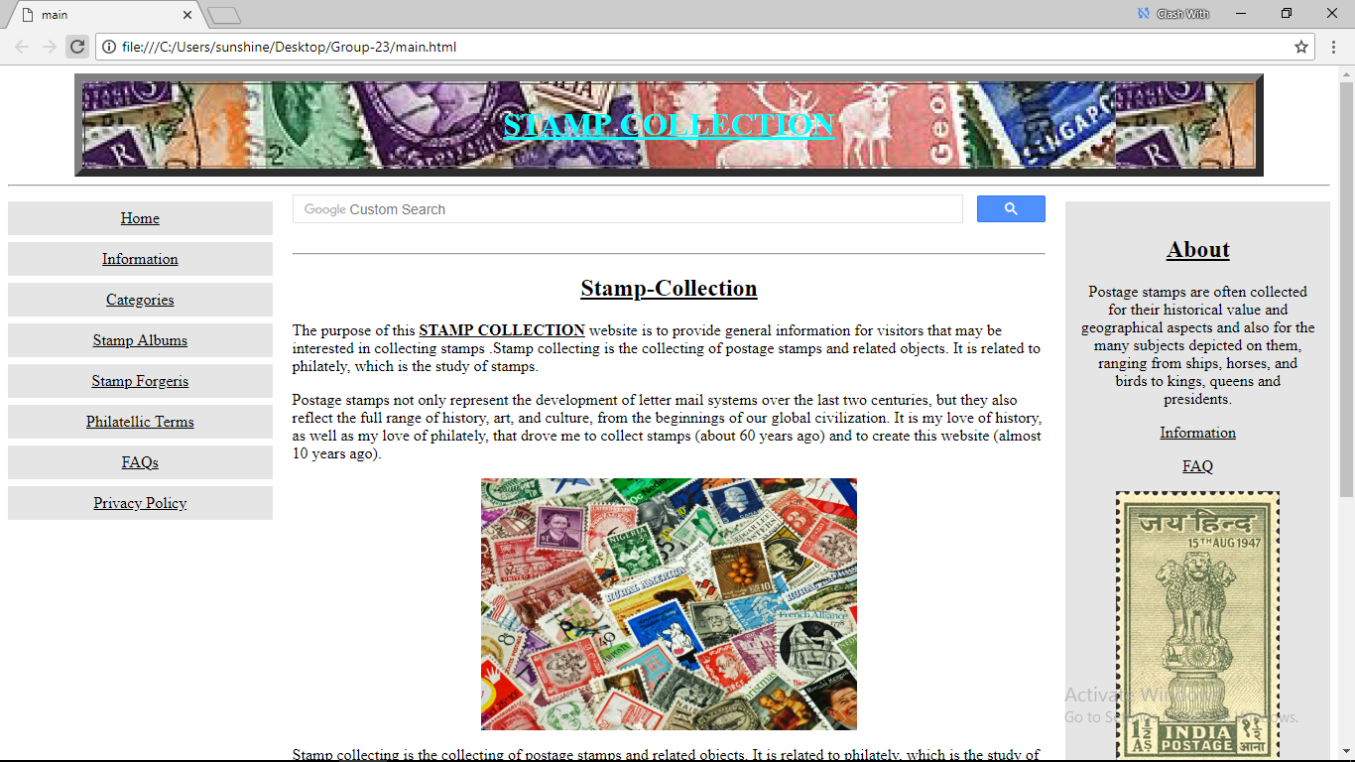

STAMP COLLECTION



The purpose of this project is to create a stamp collection website client site programming (html, css ,jquery,javascript). Through this stamp collection website one can find different stamps under different categories, the information is provided for how stamp lovers can proceed with the hobby of stamp collection. Our website provide general informationfor visitors that may be interested in collecting stamps and to provide the specialized information needs of more advanced stamp collectors and philatelists.

VARIOUS COLLECTION OF STAMPS:

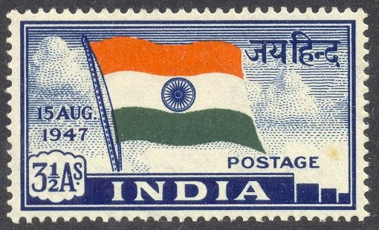 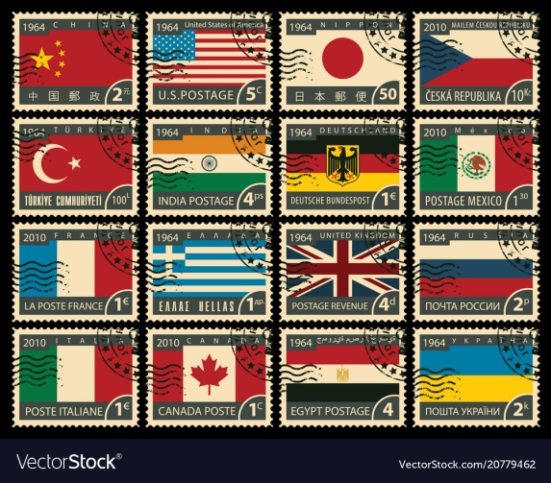

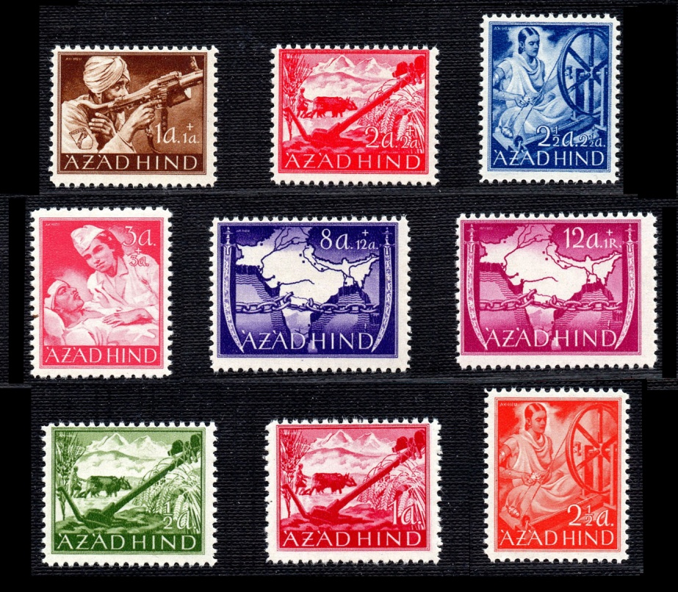

DESCRIPTION ABOUT TOPIC:

Postage stamps not only represent the development letter mail systems over the last two centuries, but they also reflect the full range of history, art, and culture, from beginnings of our global civilization. And due to their love of history and philately people tend to collect stamps. And so a stamp collection website comes in to provide information to such interested peoples. Stamp collection websites provide information free of cost to enthusiasts. A beginner who is interested in stamp collection but doesn’t have much information would always consider collecting information before collecting stamps and the stamp collection website is supposed to help such people.

Stamp collecting is generally accepted as one of the area that make up the wider subject of philately, which is the study of stamps. A philatelist may, but does not have to, collect stamps. It is not uncommon for the term philatelist to be used to mean a stamp collector. Many casual stamp collectors accumulate stamps for sheer enjoyment and relaxation without worrying about the tiny details. The creation of a large comprehensive collection, however, generally requires some philatelic knowledge and will usually contain areas of philatelic studies.

Postage stamps are often collected for their historical value and geographical aspects and also for the many subjects depicted on them, ranging from ships , horses, and birds to kings, queens and presidents.

Sales of postage stamps are important source of income for some countries whose stamp issues may exceed their postal needs, but have designs that appeal to many stamp collectors.

A world wide collection would be enormous, running to thousands of volumes, and would be incredibly expansive to acquire. Many consider that count Phillip von Ferray’s collection at the beginning of the 20th century was the most complete ever formed. Many collectors limit their collecting to particular countries, certain time periods or particular subjects(called “topicals”) like birds or aircraft.

There are thousands of organizations for collectors: local stamp clubs,special-intertest groups, and national organizations. Most nations have a national collectors’ organization, including the American Philatelic Society(APS) in the United states; the Royal Philatelic Society London and Philatelic traders society in United Kingdom; and the Royal Philatelic Society of Canada in Canada. The internet has greatly expanded the availability of information and made it easier to obtain stamps and other philatelic material. The American Topical Association is now a part of the APS and promotes thematic collecting as well as encouraging sub-groups of numerous topics.

Stamp clubs and philatelic societies can add a social aspect to stamp collecting and provide a forum where novices can meet experienced collectors. Although such organizations are often advertised in stamp magazines and online, the relatively small number of collectors – especially outside urban areas – means that a club may be difficult to set up and sustain. The Internet partially solves this problem, as the association of collectors online is not limited by geographical distance. For this reason, many highly specific stamp clubs have been established on the Web, with international membership.

Organizations such as the Cinderella Stamp Club(UK) retain hundreds of members interested in a specific aspect of collecteing. Social organizations, such as the Lions club and Rotary International, have also formed stamp collecting groups specific to those stamps that are issued from many countries wordwide that display the organizations logo

Rare stamps are often old and have many interesting stories attached to them.

It has been suggested that John Bourke, Receiver General of Stamp Dues in Ireland was the first collector. In 1774 he assembled a book of the existing embossed revenue stamps, ranging in value from 6 pounds to half a penny, as well as the hand stamped charge marks that were used with them. His collection is preserved in the Royal Irish Academy, Dublin.

Postage stamp collecting began at the same time that stamps were first issued, and by 1860 thousands of collectors and stamp dealers were appearing around the world as this new study and hobby spread across Europe, European colonies, the United states and other parts of the world.

The first postage stamp, the Penny black, was issued by Britain in May 1840 and pictured a young Queen Victoria. It was produced without perforations(imperforate) and consequently had to be cut from the sheet with scissors in order to be used. While unused examples of the Penny Black are quite scarce.

**Reference**

*Wikipedia

*https://www.stampcollectioncenter.com

**GitHub Link:**

**https://github.com/Aniket11007/Section-K19PA-G-23**

**BONAFIDE CERTIFICATE**

Certified that this project “Stamp Collection Website” is the bonafide work of Sijousa Boro and Jha Aniket Shivanand who carried out the project work under my supervision.

Dr. Dhanpratap Singh

CSE-326 INTERNET PROGRAMMING LABORATORY

UID-25706

School of Computer Science and Engineering